**Warehouse Management System**

**Introduction to Programming**

**CMPT 120L**

**Cache Me If You Can**



Marist College

School of Computer Science and Mathematics

Submitted To:

Dr. Reza Sadeghi

Date: Fall 2024

**Table of Contents**

Table of Figures…...………...…..……………………………………………………………………….……....…3 Project Descriptions ………………………………………………………………………..…………..…………..4-5 Github Link…...……………..……………………………………………………………………………….……....…5 User Experience Design……………………………………………………………………………………………6-15 Virtural Environment………………………………………………………………………………………………….16

**Table of Figures**

Figure 1 Login Page Flowchart...………...…..………………………………………………………………...………6

Figure 2 Main Menu Flowchart…………………………………………………………………………………...……7

Figure 3 Regular User Search Flowchart……………………………………………………………………………….8

Figure 4 Regular User View Favorites Flowchart…………………………………………………………………….,,9

Figure 5 Buy or Borrow Flowchart……………………………………………………………………………………10

Figure 6 View History Flowchart……………………………………………………………………………………..11

Figure 7 View Barrow Request……..…………………………………………………………………………………12

Figure 8 Manage Warehouse…………..…………………………………………………………………….………..13

Figure 9 Remove User…………………….…………………………………………………………………………..14

Figure 10 Create Guest User…………………………………………………………………………………………..15

Figure 11 CMD installing virtualenv………………………………………………………………………………….16

Figure 12 Virtual Environment being created and then run in VS code………………………………………………16

**Project Description**

PROJECT TITLE: WAREHOUSE MANAGEMENT SYSTEM

**Summary:** THE WAREHOUSE MANAGEMENT SYSTEM (WMS) PROVIDES AN ORGANIZED WAY OF STORING DIFFERENT PRODUCTS AND ELEMENTS IN A WAREHOUSE. YOU CAN CONSIDER A LIBRARY AS A WAREHOUSE, WHICH MAINTAINS BOOKS’ DETAILS AND USER LIBRARIES. A GENERAL WMS STORES DETAILS OF NAME AND IDENTIFICATION NUMBER OF PRODUCTS, THEIR STORE TIME, THE REQUIRED STORAGE CONDITION, PRICE, WEIGHT, HEIGHT, ETC. FOLLOWING THIS, THIS SYSTEM ALLOWS GUEST USERS TO SEARCH FOR DIFFERENT CONTENT AND REQUEST TO BORROW/BUY THEM. YOUR WMS WILL STORE THE DATA OF DIFFERENT USER TYPES IN DISTINCT COMMA SEPERATED VALUE (CSV) FILES. THIS SYSTEM SHOULD AT LEAST SUPPORT THE FOLLOWING ITEMS:

1. ADMIN USER IS CAPABLE OF:

a. HAVING ADMIN USER AND PASSWORD FOR LOG IN (A STRING OF AT LEAST 8 CHARACTERS)

b. CHANGING THE ADMIN USER AND ADMIN PASSWORD

c. ADDING A GUEST USER TO WMS BY CREATING A NEW USERNAME AND PASSWORD. A GUEST USER IS NOT ABLE TO DEFINE OR REMOVE OTHER USERS.

d. REMOVING USERS FROM WMS BY REMOVING THEIR USERNAME, PASSWORD, AND CORRESPONDING RECORDED DATA.

e. ADDING AN ITEM TO THE WAREHOUSE WITH VARIED DETAILS, SUCH AS:

i.TYPE: FOOD, BOOKS, CARS, ETC.

ii.STORED TIME IN THE WAREHOUSE

iii.PICK OUT TIME FROM THE WAREHOUSE

iv.ID: EACH ITEM IN YOUR LIBRARY SHOULD HAVE A

UNIQUE IDENTIFICATION NUMBER WITH A SPECIFIC

FORMAT

v.NAME

vi.PROVIDER/CREATOR’S NAME

vii.QUANTITIES: THE NUMBER OF AVAILABLE ITEMS. FOR

INSTANCE, ITEM X WITH A QUANTITY OF 2 IS A SIGN OF 2

AVAILABLE X ITEMS IN YOUR WAREHOUSE.

viii.PLACE: WHERE THE ITEM IS STORED

ix.PRICE.

f. DELETING AN ITEM FROM WAREHOUSE

g. EDITING AN ITEM IN WAREHOUSE

h. VIEWING THE LIST OF BORROWING REQUESTS

i. ACCEPTING OR REJECTING A BORROWING REQUEST

2. EACH USER SHOULD BE ABLE TO:

a. SEARCH THROUGH WMS BASED ON ALL ITEMS’ DETAILS,

SUCH AS ID, NAME, AND PRODUCER.

b. SAVE A LIST OF FAVORITE ITEMS

c. REQUEST TO BORROW/BUY SOME ITEMS FOR A SPECIFIC

TIME. FOR EXAMPLE, BORROWING ITEM A FOR 3 WEEKS.

d. VIEW THE HISTORY OF BORROWED ITEMS

3. WMS SHOULD BE A USER-FRIENDLY SOFTWARE, SUCH THAT: a. IT SHOWS A WELCOME PAGE

b. IT PROVIDES A MENU OF ALL FUNCTIONS TO THE USER IN ALL PAGES

c. IT ILLUSTRATES THE REPORTS IN A TABULAR FORM. FOR INSTANCE, IT DISPLAYS A WELL-ORGANIZED LIST OF THE REQUESTED ITEMS.

d. WMS SHOULD PROVIDE AN EXIT FUNCTION AND THANK THE USER FOR USING THIS SOFTWARE.

e. IT SHOWS A WARNING IF:

i.THE ADMIN USER TRIES TO ADD A NEW ITEM TO THE

LIBRARY WITH AN EXISTING ID.

ii.IF A GUEST USER TRIES TO BORROW MORE THAN 3 ITEMS.

iii.A USER SEARCH REQUEST RETURNS NULL ITEMS.

4. WMS SHOULD PROTECT THE USER INFORMATION, SUCH THAT: a. OPTIONAL: WMS PASSWORDS AND THE RECORDED INFORMATION SHOULD BE CIPHERED. IN THE SIMPLEST CASE, YOU CAN USE CAESAR CIPHER METHODOLOGY. THE EASIEST WAY TO UNDERSTAND THE CAESAR CIPHER IS TO THINK OF CYCLING THE POSITION OF THE LETTERS. IN A CAESAR CIPHER WITH A SHIFT OF 3, A BECOMES D, B BECOMES E, C BECOMES F, ETC. WHEN REACHING THE END OF THE ALPHABET IT CYCLES AROUND, SO X BECOMES A, Y BECOMES B, AND Z BECOMES C.

GitHub Link: <https://github.com/Bomb321/CMPT120_Project-4_Cache-Me-If-You-Can>

Login Page:

Input: Username and Password in text

Output: Valid username and password enable the user to move onto the main menu. If the username and password match the admin username and password, the user will be taken to a menu where they may change the admin password, or proceed to the admin main menu . If the password is invalid, a message is displayed informing the user that their information is invalid, and prompts them to log in again.

*Figure 1 Login Phase Flowchart [1]*

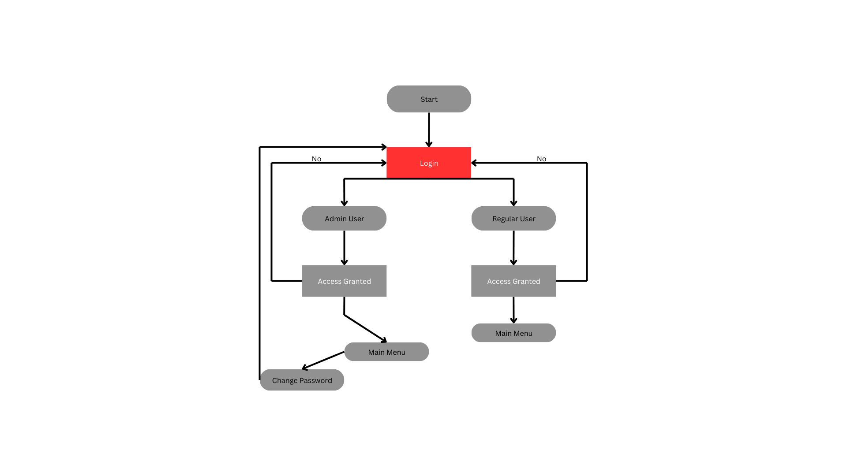

Main Menu:

Input: User will be provided with a list of options which will change depending on if the user used Admin or Regular login credentials. User will pick one option

Output: User will be taken to another page corresponding to the option they choose.

*Figure 2 Main Menu Flowchart [2]*

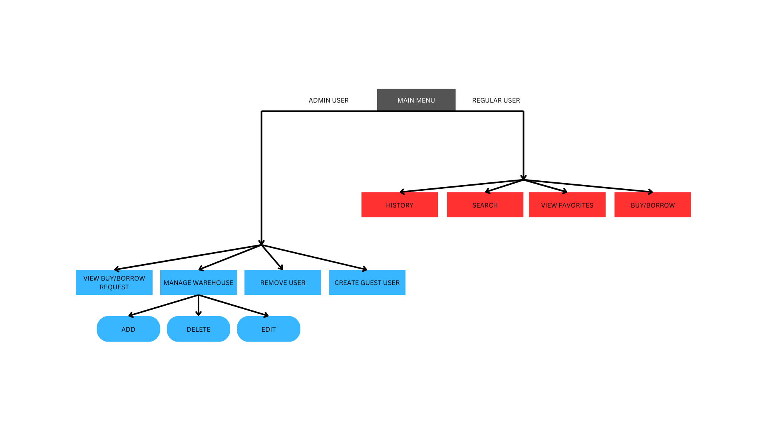

Regular User Search:

Input: Users will be prompted to choose if they want to search by ID, Product Name, or Producer. Then they will be prompted to search. After the output is provided, the user will also be prompted to add the item to their favorites list. Afterwards, they will be asked if they want to search again.

Output: A list of products, and follow up prompts asking for further inputs. If the user does not want to search again, they will be taken back to the regular user main menu,

*Figure 3 Regular User Search Flowchart [3]*

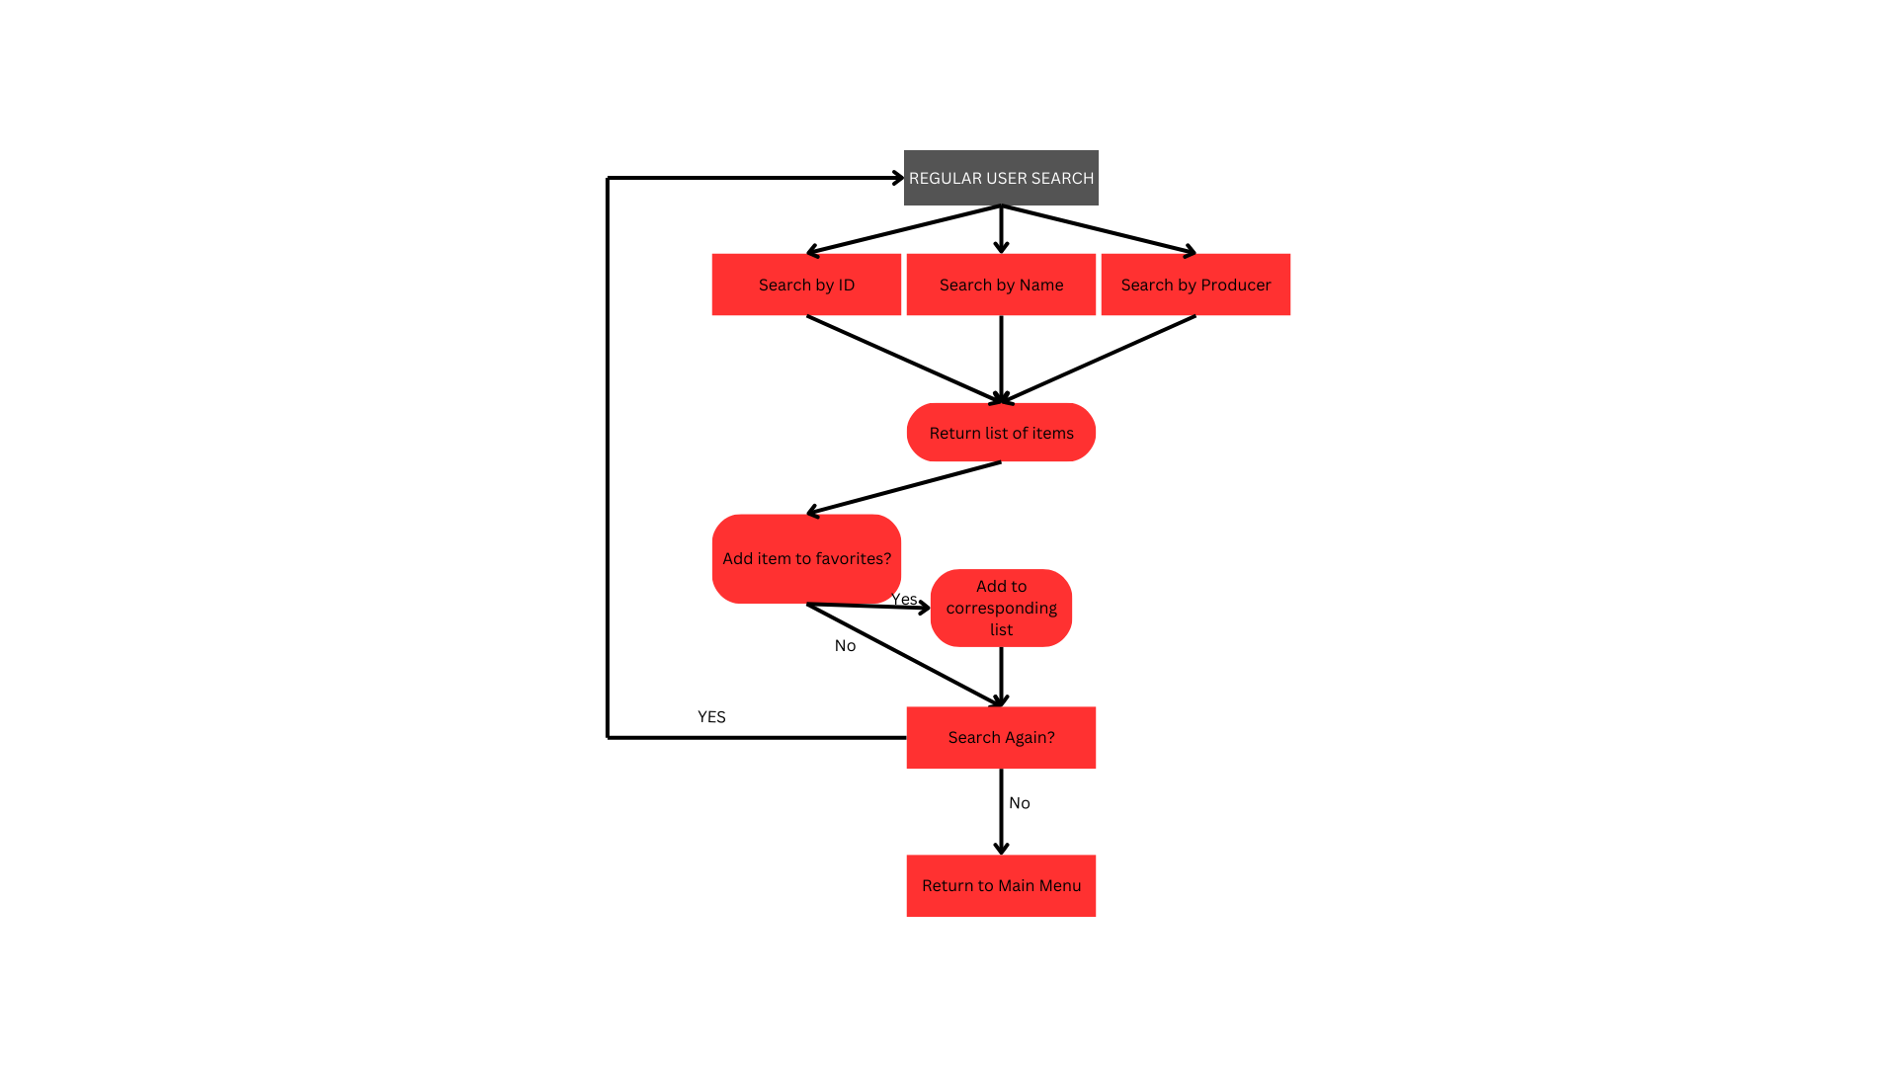

Regular User View Favorites

Input: Users will be prompted to return to the main menu.

Output: Users will be presented with a list of items in their favorite list.

*Figure 4 View Favorites Flowchart [4]*

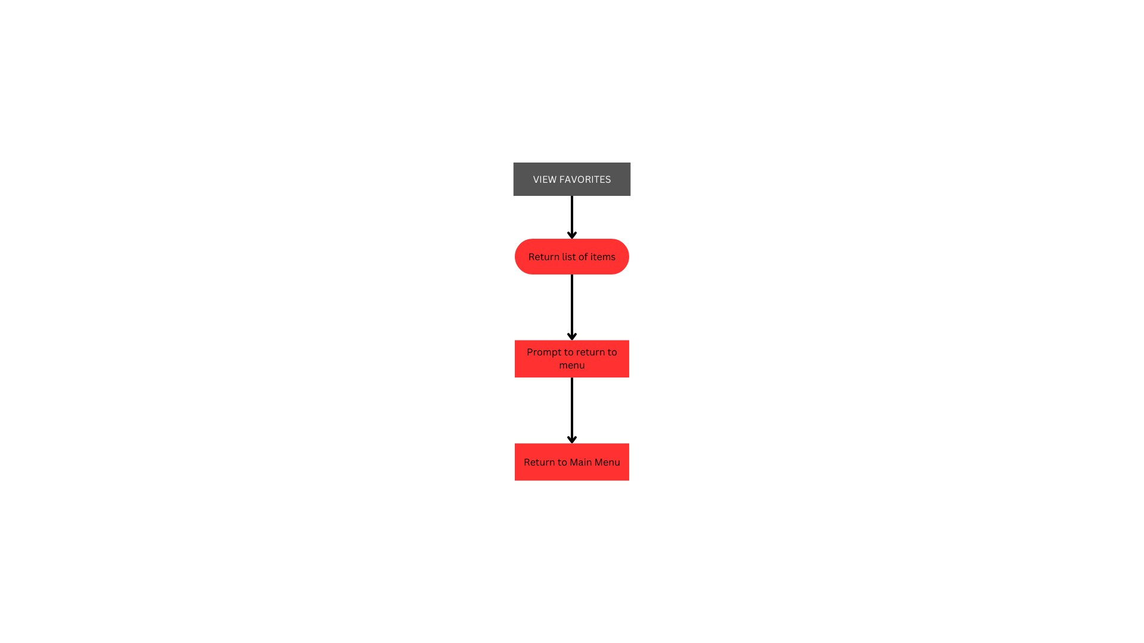

Regular User Buy or Borrow

Input: Users will be asked to provide the name of the product, if they are buying or borrowing it, and the duration of their borrowing. Users will also have the option to return to the main menu.

Output: List of items on the buy list presented after each item is added. Follow up questions are also part of output. If the product item is invalid, the user will be redirected to the first output.

*Figure 5 Buy or Borrow Flowchart [5]*

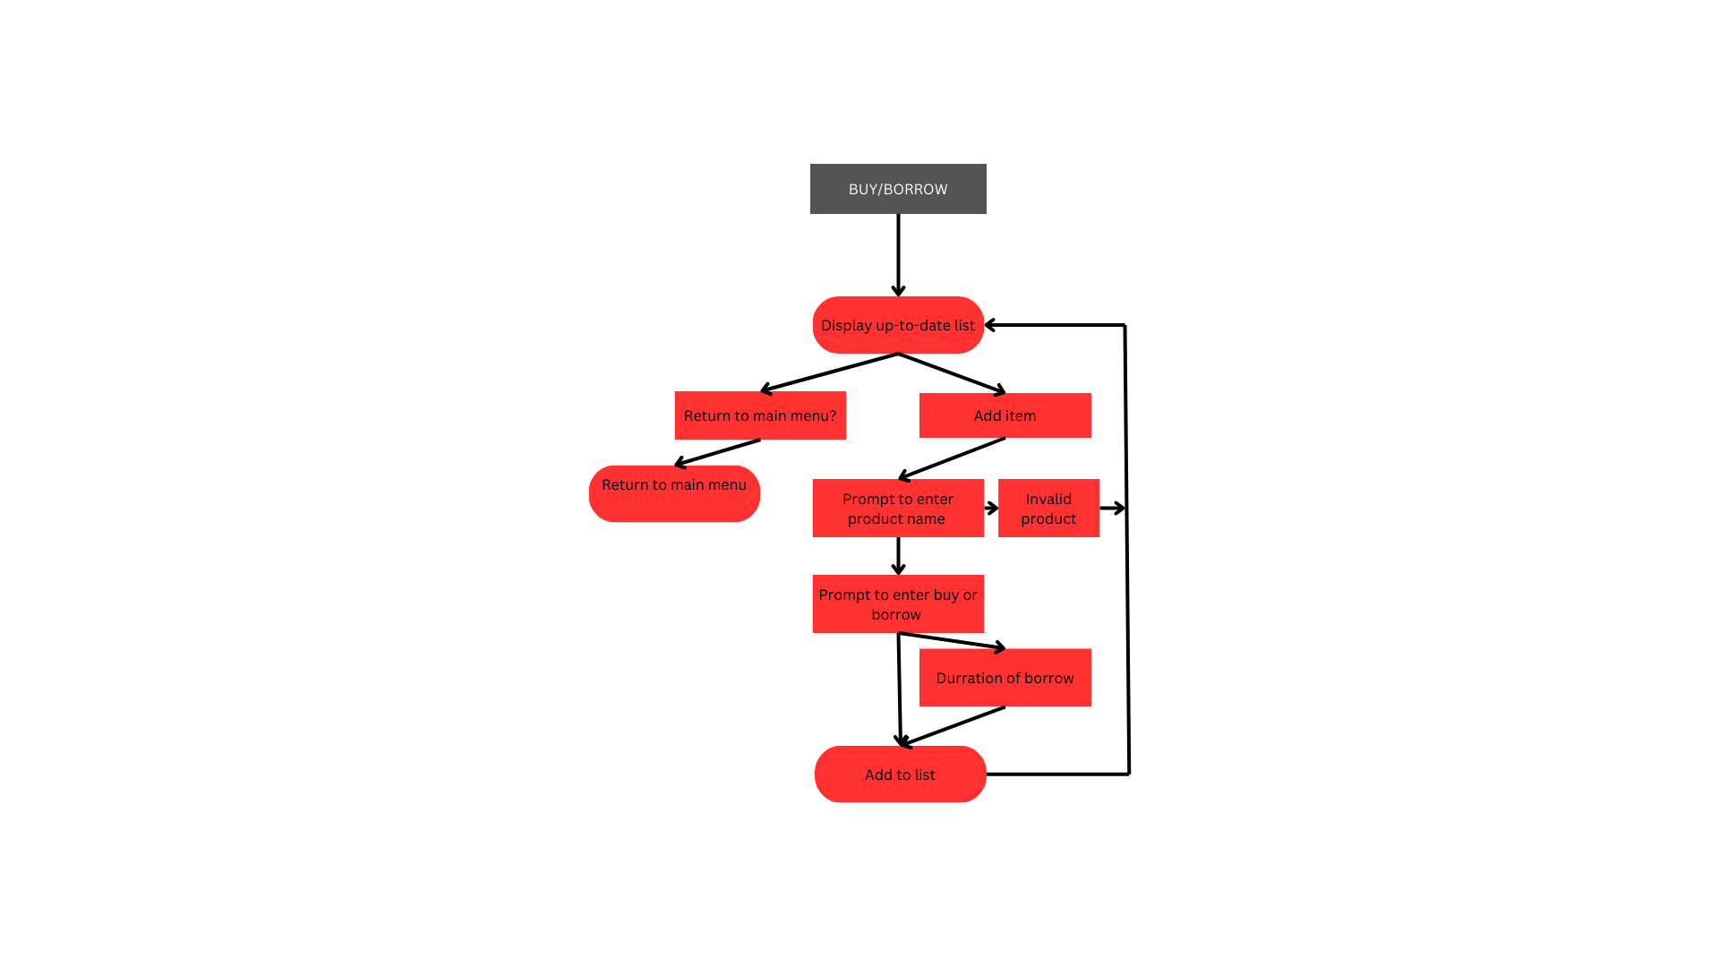

Regular User View History

Input: User will be prompted to return to the main menu after the list is read.

Output: List of all purchases or borrows, and a prompt to return to the main menu.

*Figure 6 View History Flowchart [6]*

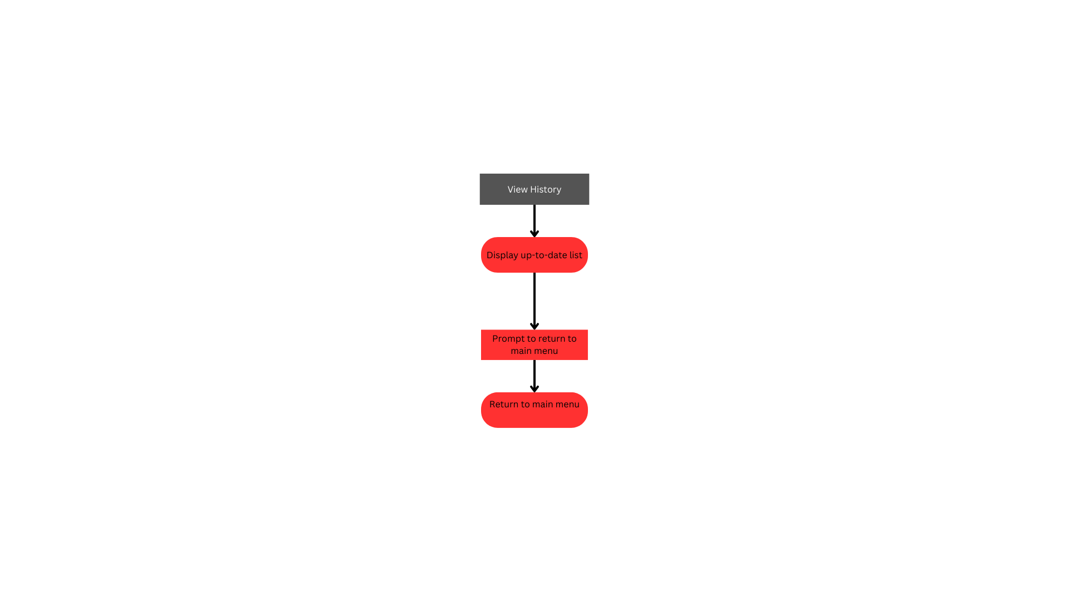

Admin View Barrow Request:

Input: The admin will be asked to search the list of all items requested to be borrowed to find specific requests. They will either accept or reject the request and be prompted to return to the main menu or review more requests.

Output: If rejected, the request will be removed. If accepted, the request will be approved and moved into warehouse management.

*Figure 7 View Barrow Request [7]*

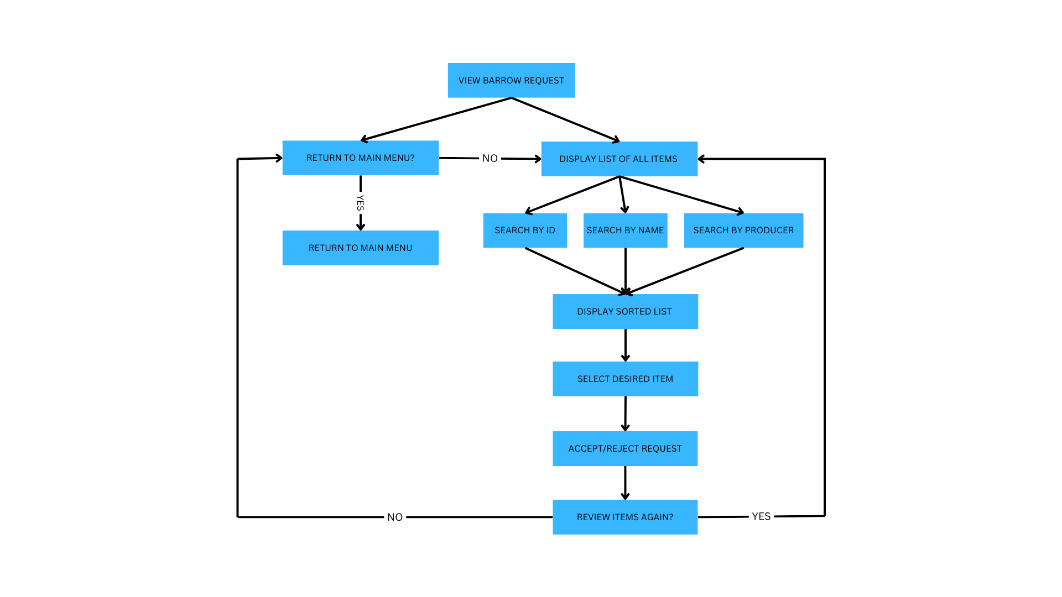

Admin Manage Warehouse:

Input: The admin will be prompted to add, delete, or edit an item from the warehouse. For accuracy, all three actions will require the product's name, ID, and producer before updating the list and prompting the admin to return to the main menu or adjust the warehouse again.

Output: The warehouse list will be updated for the regular user to view

*Figure 8 Manage Warehouse [8]*

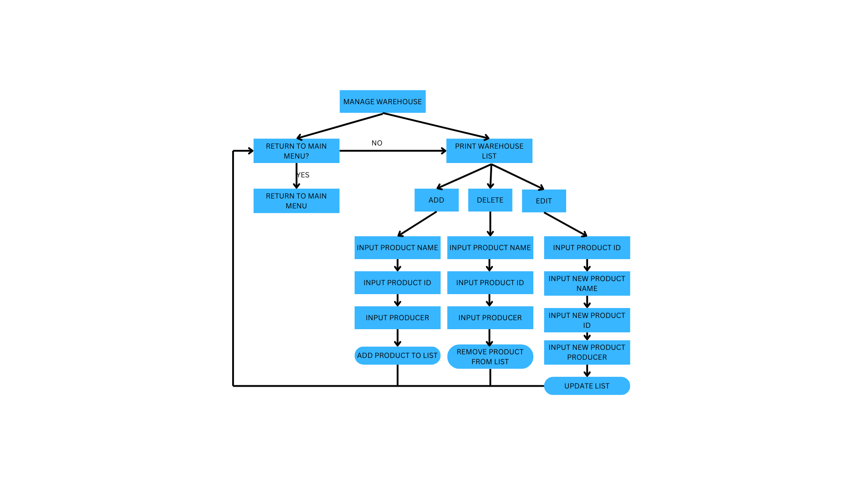

Admin Remove User:

Input: The admin will input the username and password of the desired user to remove before being prompted to confirm the removal of the user

Output: The desired user will be removed along with all of their corresponding data

*Figure 9 Remove User [9]*

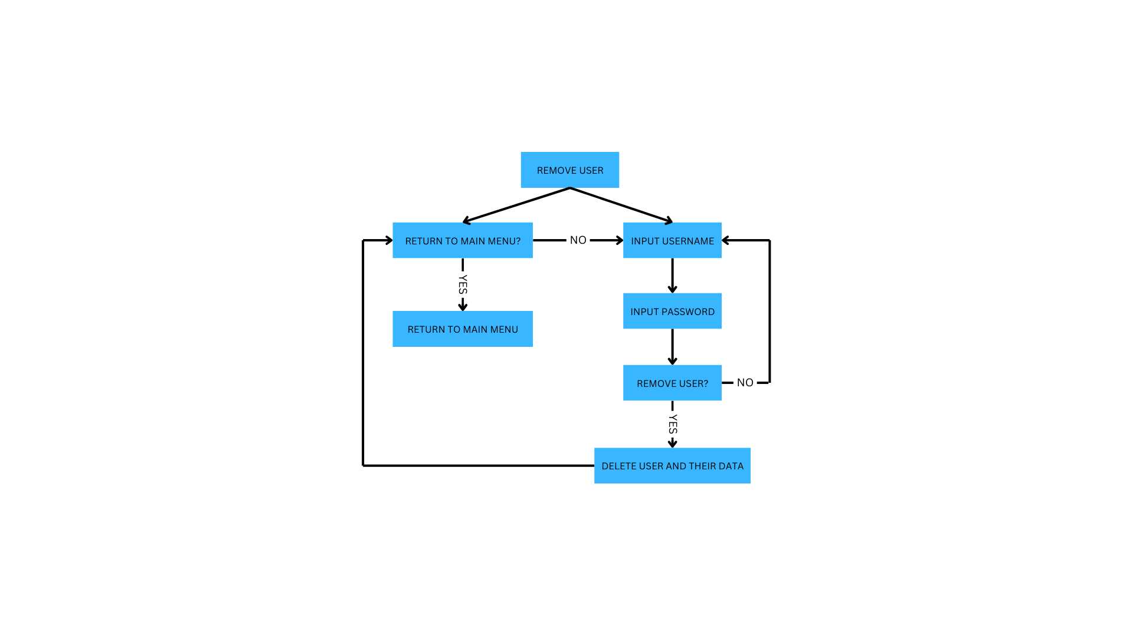

Admin Create Guest User:

Input: The admin will input a new username and password for the corresponding username

Output: New guest user created, returning to the login page for the new user to log in

*Figure 10 Create Guest User [10]*

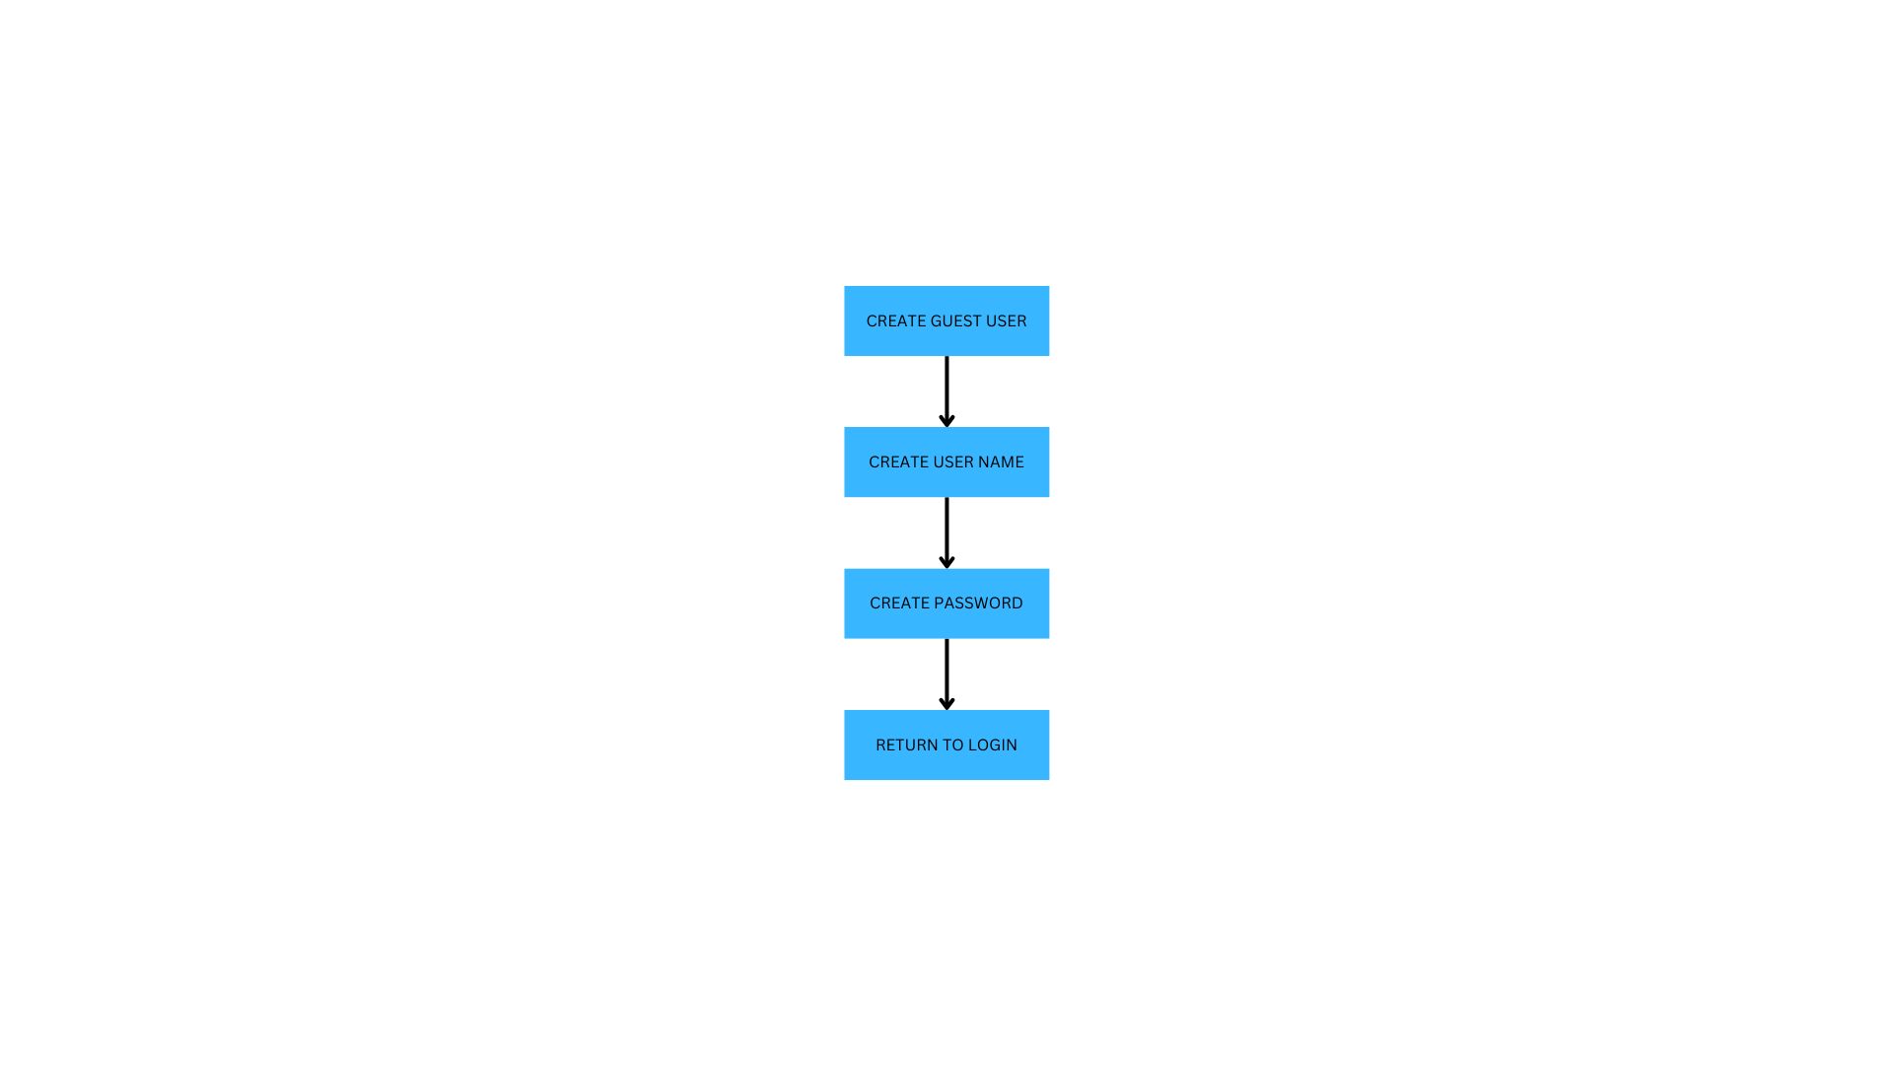

Ensure that virtualenv is installed/ install virtualenv using pip (installed with [python](https://www.python.org/))

*Figure 11 CMD installing virtualenv [11]*

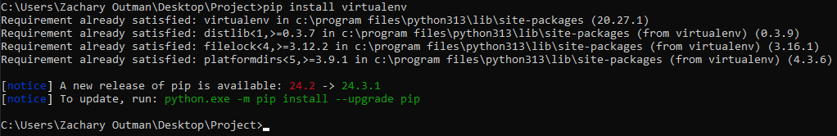

List of packages:  
pip

virtualenv

venv

Running a virtual environment in an IDE (VS Code)

*Figure 12 Virtual Environment being created then run in VS Code [12]*

